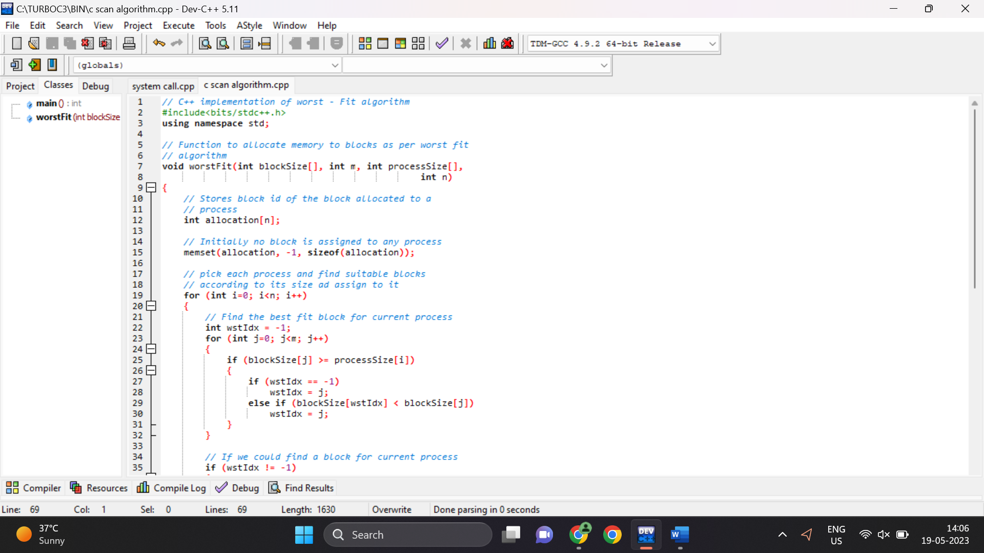

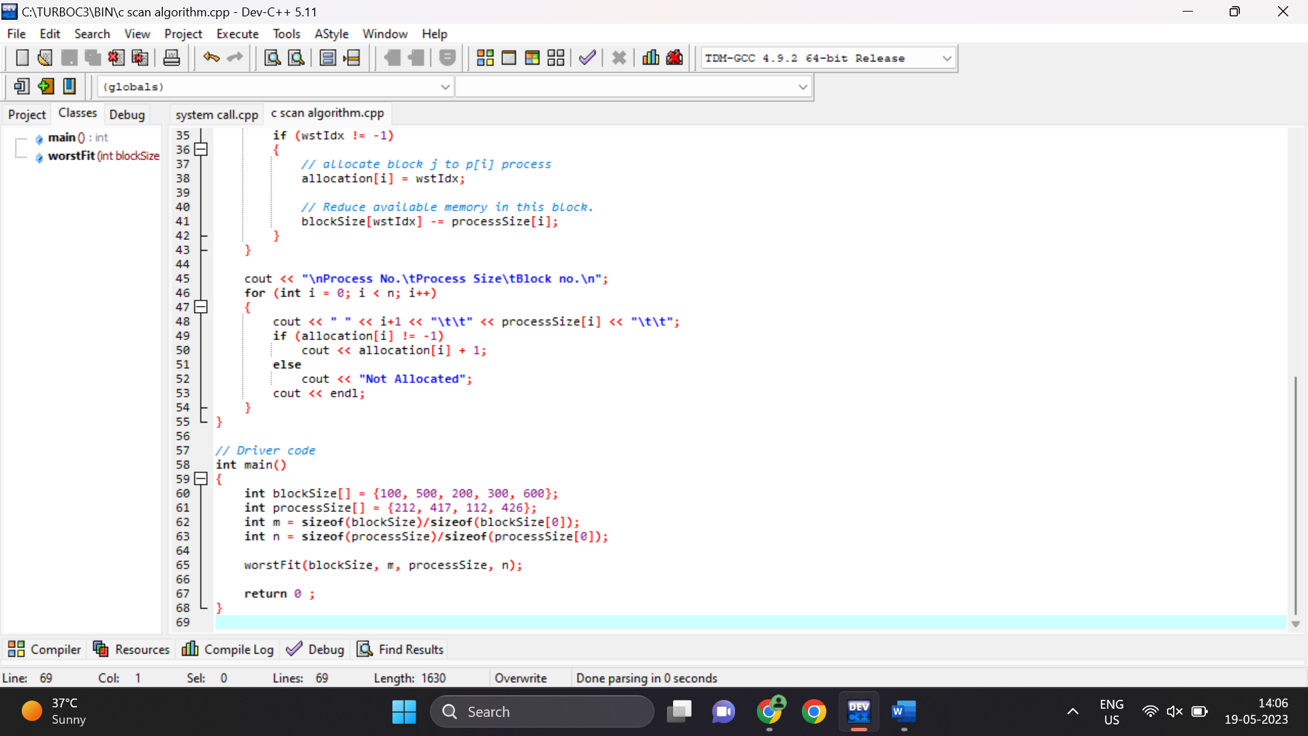

Output:

Process No. Process Size Block no.

1 212 5

2 417 2

3 112 5

4 426 Not Allocated

--------------------------------

Process exited after 0.05922 seconds with return value 0

Press any key to continue . . .